**3.1 Introduction**

Last week, we looked at doing classification using texts and trying to train and understand positive and negative sentiment in movie reviews. We finished by looking at the effect of tokenizing words, and saw that our classifier failed to get any meaningful results. The main reason for this was that the context of words was hard to follow when the words were broken down into sub-words and the sequence in which the tokens for the sub-words appear becomes very important in understanding their meaning.

The neural network is like a function that when you feed it in data and labels, it infers the rules from these, and then you can use those rules.

So it could be seen as a function a little bit like this, you take the data and you take the labels, and you get the rules. But this doesn't take any kind of sequence into account. To understand why sequences can be important, consider this set of numbers.

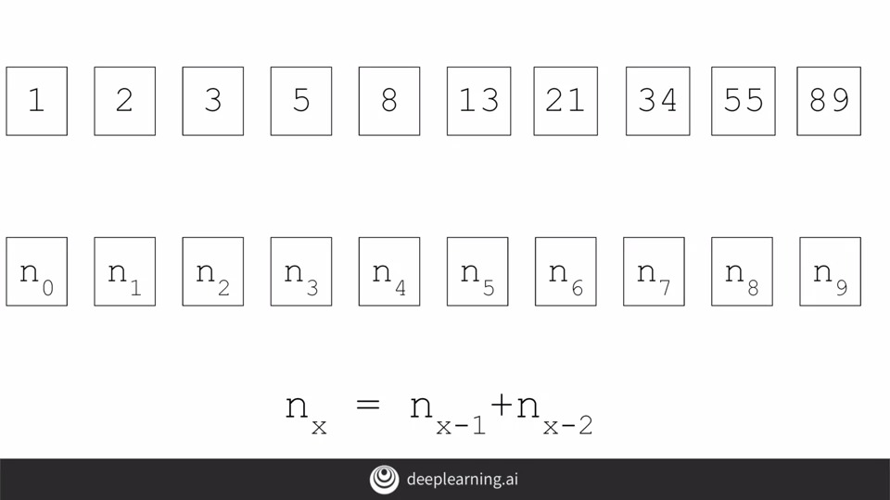

If you've never seen them before, they're called the Fibonacci sequence. So let's replace the actual values with variables such as n_0, n_1 and n_2, etc., to denote them. Then the sequence itself can be derived where a number is the sum of the two numbers before it. So 3 is 2 plus 1, 5 is 2 plus 3, 8 is 3 plus 5, etc. Our n_x equals n_x minus 1, plus n_x minus 2, where x is the position in the sequence.

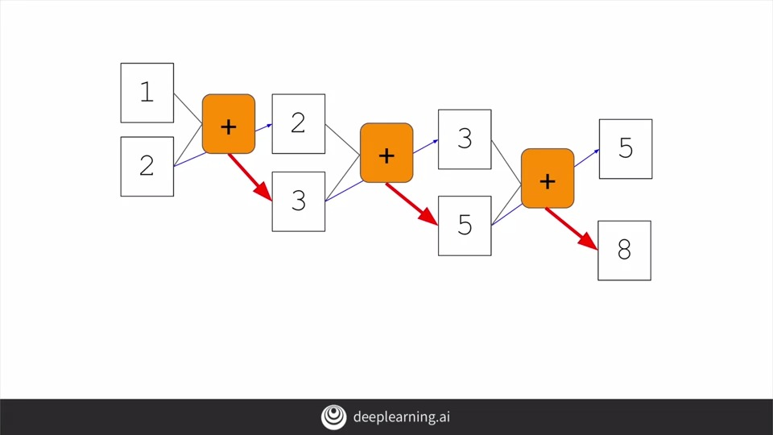

Visualized, it might also look like this, one and two feed into the first function and three comes out. Two gets carried over to the next, where it's fed in along with the three to give us a five. The three is carried on to the next where it's fed into the function along with the five to get an eight and so on.

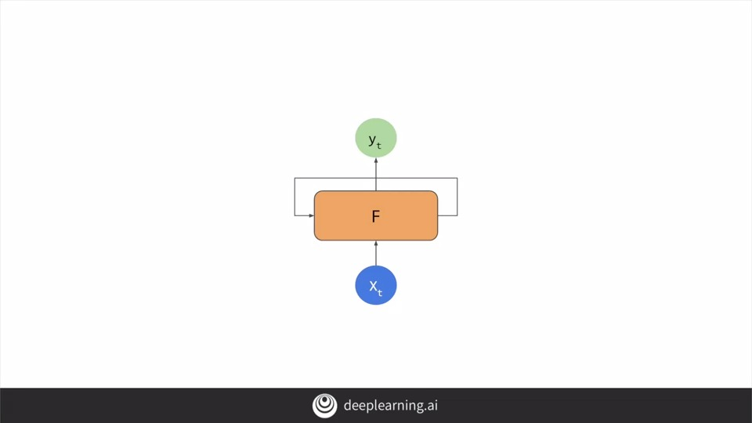

This is similar to the basic idea of a recurrent neural network or RNN, which is often drawn a little like this. You have your x as in input and your y as an output. But there's also an element that's fed into the function from a previous function.

That becomes a little more clear when you chain them together like this, x_0 is fed into the function returning y_0. An output from the function is then fed into the next function, which gets fed into the function along with x_2 to get y_2, producing an output and continuing the sequence. As you can see, there's an element of x_0 fed all the way through the network, similar with x_1 and x_2 etc. This forms the basis of the recurrent neural network or RNN. I'm not going to go into detail and how they work, but you can learn much more about them at this course from Andrew.

**3.2 LSTMs**

There can be a limitation when approaching text classification in this way. Consider the following. Here's a sentence.

Today has a beautiful blue. What do you think would come next? Probably sky. Right? Today has a beautiful blue sky. Why would you say that? Well, there's a big clue in the word blue. In a context like this, it's quite likely that when we're talking about a beautiful blue something, we mean a beautiful blue sky. So, the context word that helps us understand the next word is very close to the word that we're interested in.

But, what about a sentence like this, I lived in Ireland so at school they made me learn how to speak something. How would you finish that sentence? Well, you might say Irish but you'd be much more accurate if you said, I lived in Ireland so at school they made me learn how to speak Gaelic. First of course, is the syntactic issue. Irish describes the people, Gaelic describes the language. **But more importantly in the ML context is the key word that gives us the details about the language**. That's the word Ireland, which appears much earlier in the sentence. So, if we're looking at a sequence of words we might lose that context.

With that in mind an update to RNNs is called LSTM, long short - term memory has been created. In addition to the context being PaaSed as it is in RNNs, LSTMs have an additional pipeline of contexts called cell state. This can pass through the network to impact it. This helps keep context from earlier tokens relevance in later ones so issues like the one that we just discussed can be avoided. Cell states can also be bidirectional. So later contexts can impact earlier ones as we'll see when we look at the code.

**3.3 Implementing LSTMs in code**

So let's now take a look at how to implement LSTMs in code.

Here's my model where I've added the second layer as an LSTM. I use the tf.keras.layers.LSTM to do so. The parameter passed in is the number of outputs that I desire from that layer, in this case it's 64. If I wrap that with tf.keras.layers.Bidirectional, it will make my cell state go in both directions.

You'll see this when you explore the model summary, which looks like this. We have our embedding and our bidirectional containing the LSTM, followed by the two dense layers. If you notice the output from the bidirectional is now a 128, even though we told our LSTM that we wanted 64, the bidirectional doubles this up to a 128. Y

You can also stack LSTMs like any other keras layer by using code like this. But when you feed an LSTM into another one, you do have to put the return sequences equal true parameter into the first one. This ensures that the outputs of the LSTM match the desired inputs of the next one.

The summary of the model will look like this. Let's look at the impact of using an LSTM on the model that we looked at in the last module, where we had subword tokens.

**3.4 Accuracy and loss**

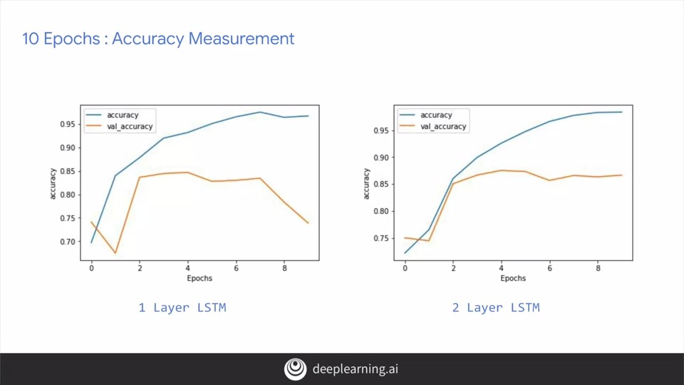

Here's the comparison of accuracies between the one layer LSTM and the two layer one over 10 epochs. There's not much of a difference except the nosedive and the validation accuracy. But notice how the training curve is smoother. I found from training networks that jaggedness can be an indication that your model needs improvement, and the single LSTM that you can see here is not the smoothest. If you look at loss, over the first 10 epochs, we can see similar results.

But look what happens when we increase to 50 epochs training. Our one layer LSTM, while climbing in accuracy, is also prone to some pretty sharp dips. The final result might be good, but those dips makes me suspicious about the overall accuracy of the model. Our two layer one looks much smoother, and as such makes me much more confident in its results. Note also the validation accuracy. Considering it levels out at about 80 percent, it's not bad given that the training set and the test set were both 25,000 reviews. But we're using 8,000 sub-words taken only from the training set. So there would be many tokens in the test sets that would be out of vocabulary. Yet despite that, we are still at about 80 percent accuracy.

Our loss results are similar with the two layer having a much smoother curve. The loss is increasing epoch by epoch. So that's worth monitoring to see if it flattens out in later epochs as would be desired. I hope this was a good introduction into how RNNs and LSTMs can help you with text classification. Their inherent sequencing is great for predicting unseen text if you want to generate some, and we'll see that next week. But first, I'd like to explore some other RNN types, and you'll see those in the next video.

3.5 A word from Laurence

In the last video we saw LSTMs and how they work with cell state to help keep context in a way that helps with understanding language. Well, words that aren't immediate neighbors can affect each other's context.

In this video, you'll see some other options of RNN including convolutions, Gated Recurrent Units also called GRUs, and more on how you can write the code for them. You'll investigate the impact that they have on training. I'm not going to go into depth on how they work, and that information is available in the deep learning specialization from Andrew. So do check it out there.

3.6 Looking into the code

3.7 Using a convolutional network

3.8 Going back to the IMDB dataset

3.9 Tips from Laurence